

|  |  |  |  |  |  |  |  |  |
| --- | --- | --- | --- | --- | --- | --- | --- | --- |
|  | | | | | | | | |
|  | | Digital Forensics Report | | | | |  | |
|  |  | | | | | | |  |
|  | | | |  |  | | | |
|  | | | | CASE: User Locked Up / Potential Breach |  | | | |
|  | | | | CASE #:A-00001—DATE/TIME OF INCIDENT: 11/30/2009—PREPARED BY:CESAR MUNGUIA |  | | | |
|  | | |  | | |  | | |

## Table of Contents

### 1 Introduction

### 1.1 Summary of case and tasking

### 1.2 Statement of compliance

### 2 Forensic Examination

### 2.1 Tools

### 2.2 Chain of custody

### 2.3 Dead-image examination

### 2.4 Live examination

### 3 Summary of Conclusions Reached

### 3.1 Expert opinion regarding findings

### 4 References

### 5 Appendix A

### 5.1 Exhibits/Evidence

### 

##### Introduction

The purpose of this report is to provide corroborative evidence of the motivation, opportunity and intent leading to the ex-filtration of confidential data by suspects George Ofdajungle and Mike Wizouski. The facts presented within this report are those within the preparer’s own area of expertise and knowledge and do not extend to matters and knowledge outside such expertise.

##### Summary of case and tasking

George Ofdajungle and Mike Wizouski are senior scientists employed by Astral Labs Inc, who are working on a very important experiment for the company. During a network breach, it was determined that data was ex-filtrated from their computer. My task is to examine the machine and determine if there are any forensic artifacts that might yield some information as to what the attacker stole and/or how they gained access to the network.

##### Statement of compliance

I understand my duty as an expert witness to provide independent assistance by way of objective unbiased opinion in relation to matters within my expertise. I will inform all parties in the event that my opinion changes on any material issues.

##### Forensic Examination

All examinations, measurements, tests, and experiments related to the digital image of the accused’s computer were performed by the expert and we have summarized our findings on which the expert relies.

##### Tools

* Forensic software and graphical interface – Autopsy/FTK Imager
* Network protocol analyzer - Wireshark
* Commands – sysinternals using Command Prompt

To the expert’s knowledge, there is no software in use above that possesses any material issues whose severity would invalidate the findings thereof.

##### Chain of custody

Case Number: A-00001 Offense: Potential Data Ex-Filtration

Submitting Officer: (Name/ID#): Cesar Munguia

Victim: Windows 7 PC

Suspect(s): George Ofdajungle and Mike Wizouski

Date/Time Seized: 11/30/2009 Location of Seizure: Corporate Headquarters

|  |  |  |
| --- | --- | --- |
| **Description of Evidence** | | |
| **Item #** | **Quantity** | **Description of Item** (Model, Serial #, Condition, Marks, Scratches) |
| 1 | 1 | Windows 7 PC Model XXXXX |
|  |  | Serial No: AAAAA |
|  |  | Size 500 GB |
|  |  | Condition: No significant marks, scratches, and/or damages |
|  |  |  |
|  |  |  |
|  |  |  |
|  |  |  |
|  |  |  |

|  |  |  |  |  |
| --- | --- | --- | --- | --- |
| **Chain of Custody** | | | | |
| **Item #** | **Date/Time** | **Released by** (Signature & ID#) | **Received by** (Signature & ID#) | **Comments/Location** |
| 1 | 10/30/2023 | Ian Burres | Cesar Munguia | User has been locked up from his account. No known malicious activity yet.  Location: The PC has not been moved from its current place nor has been disconnected from the network. It was only turned off for forensic examination. |
| 2 | 10/30/2023 | Ian Burres | Cesar Munguia | Image of disk:  Win7_FORENSICS-disk001  Image obtained is of  19,028,049,920 bytes  MD5 checksum:  4f5dd900661af9f9eebf5f5ccb7a3f0e  SHA1 checksum:  595cdcdfb73013396059d97a05158e055e060e71 |
| 3 | 10/30/2023 | Ian Burres | Cesar Munguia | Image:  Win7_FORENSICS.ova  Image obtained is of  7,600,046,080 bytes |

##### 

##### Dead-image examination

In this particular situation I utilized both FTK Imager and Autopsy to analyze the hard disk of the Windows 7 PC. Even though all of this process is virtualized I will pretend that I’m working with a physical Windows 7 and its disk. So, since this lab requires virtualization, the first step I took was to download the Windows 7.ova file that the professor provided to us. Then, I went to the process of importing a new appliance in VirtualBox without checking the VDI box and importing all MAC addresses. After the process was done, I went ahead and opened FTK Imager and created a new disk image, which in this case is the Windows 7 disk. I follow the usual process and created a new E01 file named “Lab4.e01”. This file was going to help me load the victim’s hard disk into both Autopsy and FTK Imager. The reason I used both was because I wanted to double-check that I was able to discover the same findings. From this point and forward I have already loaded the E01 file into both programs successfully and it’s time to dive into the investigation.

My first thought was to check the IEUser directory since this is the account that is currently locked, so looking at this directory would hopefully give me some helpful hints about what might’ve happened with the suspects and the potential breach. I opened the directory and started analyzing all the folders under that account. Most of it looked normal to me at first, but then I started noticing some suspicious folders like “Foreign Contact” and “Top Secret Experiment”. I opened the “Foreign Contact” folder and noticed that there was a file containing all the messages between suspect George and an unknown individual (refer to evidence 1). I learned that there was going to be an exchange between the unknown solicitor and George. Such solicitor was going to pay him about 50 million for a copy of their current research. This file is extremely important because it can be used as evidence against these users, so I flagged it for future use. Then, I began an overview of the “Top Secret Experiment” and found out that it was a folder containing Mike’s notes about the new experiment the company has been working for years and very important intellectual property. For that reason, I decided to flagged this directory also for future use and evidence (refer to evidence 2). Lastly, I decided to check again for significant pieces of evidence and I thought about checking the “Saved Email” directory because it could have important messages detailing more evidence. As I opened the folder, I found out that there was in fact more evidence because it had email messages from both the foreign solicitor and George. I flagged this folder for future use and evidence. One of the messages that George has sent stated that he was going to set up an FTP server for the data exchange because he suspected that he was about to get caught by the firm. The email message included the log in credentials for the server and I considered this to be very useful information that I could use to uncover the case (refer to evidence 3). Lastly, I learned that George actually used the FTP server to transfer all the important information about the research. I was able to confirm this because under the “inetpub” directory there was a “ftproot” folder which contained all the stolen data (refer to evidence 4). These were all the significant evidence artifacts I was able to find during the dead-image exam.

##### Live examination

Since I didn’t currently have access to the IEUser that was locked up, my first objective was to get an IP address for the Windows 7 machine so that I could run a Nmap scan. We’re pretending that the compromised computer was a computer in an internal network within the corporation. So, in order for a SOC team to be able to conduct a live examination the computer needs to appear in the network so that one can have access to it in some extend. Since the whole process was virtualized my first thought/idea was to create a network between a Flare VM and the Windows 7 VM. I had several options to choose from in order for the computers to be in the same network and to be able to communicate with each other. My first option was to use the NAT option in the Network settings of each VM, this would give Internet access to the VM’s which they could then try to update themselves. My second option was to use the intnet option in the Network settings of each VM, and my third and option was to add a PfSense machine that would serve as a router/firewall. I opted to choose a version of the first option but instead of using only NAT I used instead the NATNetwork option. This would automatically give an IP address to both my Flare VM and the Windows 7 VM. Now that I have both machines in the same network let’s find out which IP address is assigned to the Windows 7 machine without using the login credentials. I have my Flare VM up and running in VirtualBox, my first step was to turn on the compromised computer and check the arp table in the Flare VM to see which IPs appear on the list. For this I used command **arp -a** and I also used command **ipconfig** to check the IP address given to the Flare VM which in this case is 10.0.2.15 (refer to exhibit 5 to view the outputs). Now, I know the IP for Flare and for the other VM I would have to go to the settings in virtual box to see the actual MAC address for the Windows 7 and compare to the arp output and match the according IP address. In Windows 7 VM network settings I found out that the MAC address was 08002710B8D0 (refer to exhibit 6) and so the appropriate IP address for this particular machine is 10.0.2.4. An important aspect about this is that under “Type” it shows that the IP is dynamically addressed, which it could potentially change in case I turn off my host computer and it assigns a different IP with subnet 10.0.2.255. However, I strongly believe that the chances of getting a different IP every time I run it is very low.

Setting up the network was one thing; the next thing will be focused on the actual analysis of the machine when it’s turned on. According to our professor there are about 13 steps that one should follow if we want to have a good overview of the volatile data in the computer. I will try my best to execute each step of the list to try to gain a better understanding of the environment. From the work I have done in the dead-image examination I tried to build the pieces together by using the most valuable piece of collected information, which was the password. According to George, the password for the FTP server connection was “showMeTheMoney99” and I wondered if this password could possibly be the password for the IEUser that was locked up. For that reason, I tried typing the password and it worked. I also double-checked that IP address was still the same, and it was (refer to exhibit 10).

My next step would be to record the system date and time to check if the time was changed. So, I ran the Command Prompt as Administrator, then I used command echo %date% %time% & tzutil /g to provide the current date and time along with the time zone. Refer to exhibit 11 for the output of the command. No time was changed.

My next step is to look if there are any significant current network connections. A malicious user could’ve potentially established a connection with the Windows 7 machine. So, for that I used command arp -a (the output is shown in exhibit 10). No suspicious connections were found.

Since I’ve discovered the actual IP address of the compromised computer, I am able to execute a nmap scan to check for vulnerabilities and gain other useful/significant information which is my next step in the list. While in the command prompt in Flare VM I used command **nmap -A -T5 -O 10.0.2.4 -sC >> scan-info.txt**. This command can be described as an aggressive scan that would give me information about all open ports, information about the operating system, information about some vulnerabilities (if there are any), and finally all of this output would be appended to the file “scan-info.txt”. After the scan was done, I opened the file to see the output (refer to exhibit 7). The open ports are port 22 (ssh), port 135 (msrpc), port 139 (netbios-ssn), port port 445 (microsoft-ds), and finally port 5357 (http). The best guess for the operating system is that it’s most likely to be Microsoft Windows Vista/7. Some vulnerabilities are as shown in exhibit 8. My next approach was to try to see if there was any suspicious or “out-of-the-ordinary” data being transferred to and from 10.0.2.4 (Windows 7). For that reason, I started the Wireshark application in the Flare machine listening to the Ethernet interface. I let it sit for about 600 seconds (10 minutes) to see if I was able to pull out some significant information. Exhibit 9 shows an overview of packets sent from and to 10.0.2.5. As I reviewed all the packets being transferred in the network, I was not able to find anything significant that would indicate me if, for example, there was a malicious service in the Windows 7 machine that might’ve been sending or retrieving packets in the network. The only things I was able to see were the ICMP packets whenever I ping-ed the Flare machine via the Windows 7 to check for availability, as well as some DHCP, BROWSER, IGMPv3 and LLMNR packets. Nothing suspicious in the network for now.

The next step is to check if there are any executables files opening TCP or UDP ports. Using the tools/sysinternals directory I executed procmon.exe and procexp.exe to get me an overview of the process that could give me some type of clue that they’re malicious. Since I knew that there weren’t any connections established to the computer from whenever I checked the arp table, I had a strong feeling that there weren’t going to be any files opening ports to listen to. Either way I still investigated the output of both programs. I opened procmon.exe and there wasn’t anything that I saw that seemed suspicious at all. There were a lot of processes running but they all seem to be system/windows process or processes that are usually always running whenever a computer is turned on (refer to exhibit 12). Only the shown process was using UDP protocols but nothing out of the usual. In the procexp.exe program and again there wasn’t anything suspicious about the processes (refer to exhibit 13). I could say that the most “active” executable that has many processes is the svchost.exe.

I then checked for the cached NetBIOS name table using the ShareEnum program in the sysinternals but failed to find something significant (refer to exhibit 14). Then I checked for and users currently logged on to the computer and for that I used the PSLoggedOn.exe program. The output of the program gave some interesting information about users logged on locally and these were the following users: IEWIN7\IEUser, IEWIN7\sshd_server, and IEWIN7\Admin. The IEUser (which is me) was logged on today by me and the other two had an unknown time (refer to exhibit 15). I also used the logonsessions.exe program to view the logon session information (refer to exhibit 16). The only session that stood out to me was a session made by user NT AUTHORITY\ANONYMOUS LOGON and user IEWIN7\sshd_server (refer to exhibit 17). Then I checked for the internal routing table using command netstat -rn (refer to exhibit 18). Then I was supposed to check for the process list using pslist.exe but I have kind of already done that whenever I used the procmon.exe program. However, the actual output of pslist.exe is shown in exhibit 19. I tried searching for running services using the psservice.exe program but I was unable to grasp an overview of some services for the simple reason that the output was never ending. Meaning there was a significant big number of services running in the computer and I couldn’t also fit them all into one screenshot. I also checked for any files that could’ve been opened remotely by someone else. I used command psfile.exe and the output showed that there were not any files opened remotely. My final step was to conduct a full system memory dumb. For that I utilized Redline and followed all the steps from the instructor’s lecture notes and his configurations. I transfer the analysis directory to the Windows 7 and ran the RunRedlineAudit executable file to capture all the memory data. Then I transferred back the directory to my flare VM and started my analysis. I looked at the registry hives and this was the result (refer to evidence 20). I looked at the event logs and noticed that there was a user account that was changed called Admin. The user that was logged in March 23, 2023 tried to change the password and changed several times to that user (refer to evidence 21).

##### Summary of conclusions reached

Based on all of the findings made there could be an approximate storyline that would describe the situation that has happened. George and Mike were normally working with their research experiment when they received a message from Demitri (a mafia member) saying that they would get 50 million dollars in exchange of some valuable data (the firm’s intellectual property). These two individuals were driven by the large amount of money they would receive if they somewhat were able to transfer him the data he was asking for. For that, George’s first action was to set up an FTP server that would allow him to send the information. After the transfer of information was made it’s more than probably that George was outplayed because probably never received the money and the “mafia member” kept the intellectual property. Finally, even though I was not able to find any hard evidence on whether the malicious user injected something into the computer my most approximate guess is that he installed malware in the computer, changed the password of the Administrator account, and finally, George more than likely changed the password of the IEUser account.

##### References

*Digital Forensic Report Sample*. online.fliphtml5.com. (n.d.). https://online.fliphtml5.com/rllbc/zdmn/#p=5

##### Appendix A

##### Exhibits/Evidence

#### Evidence 1

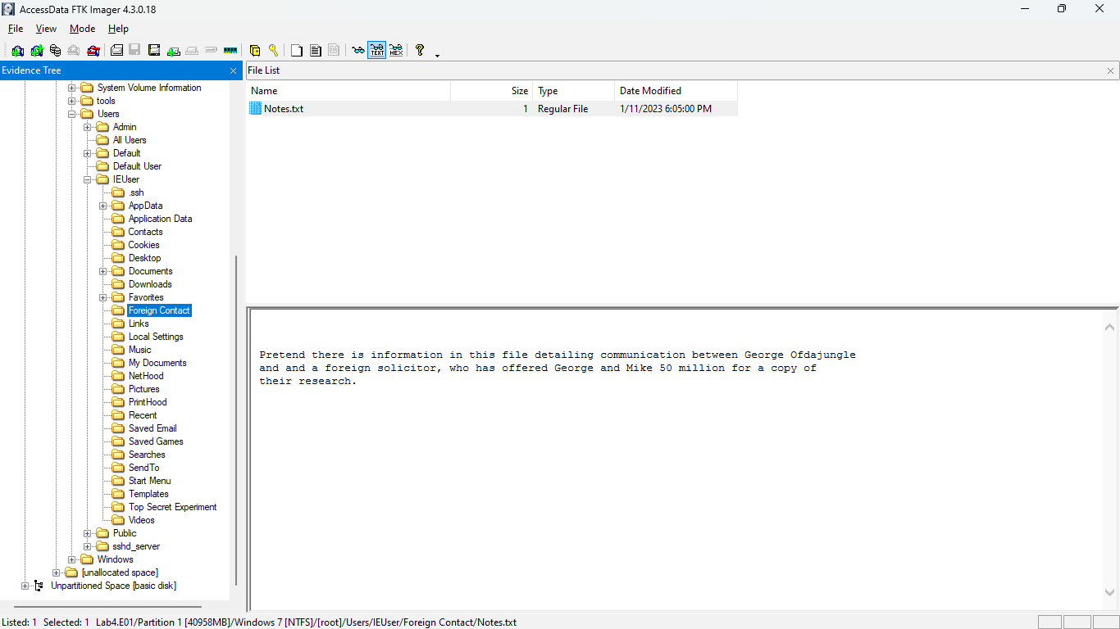

#### Evidence 2

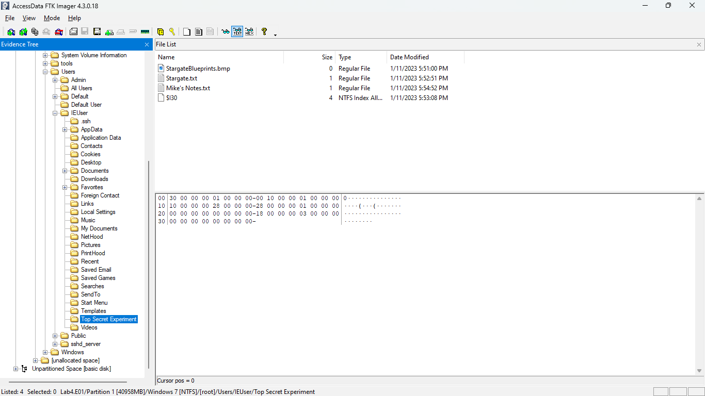

#### Evidence 3

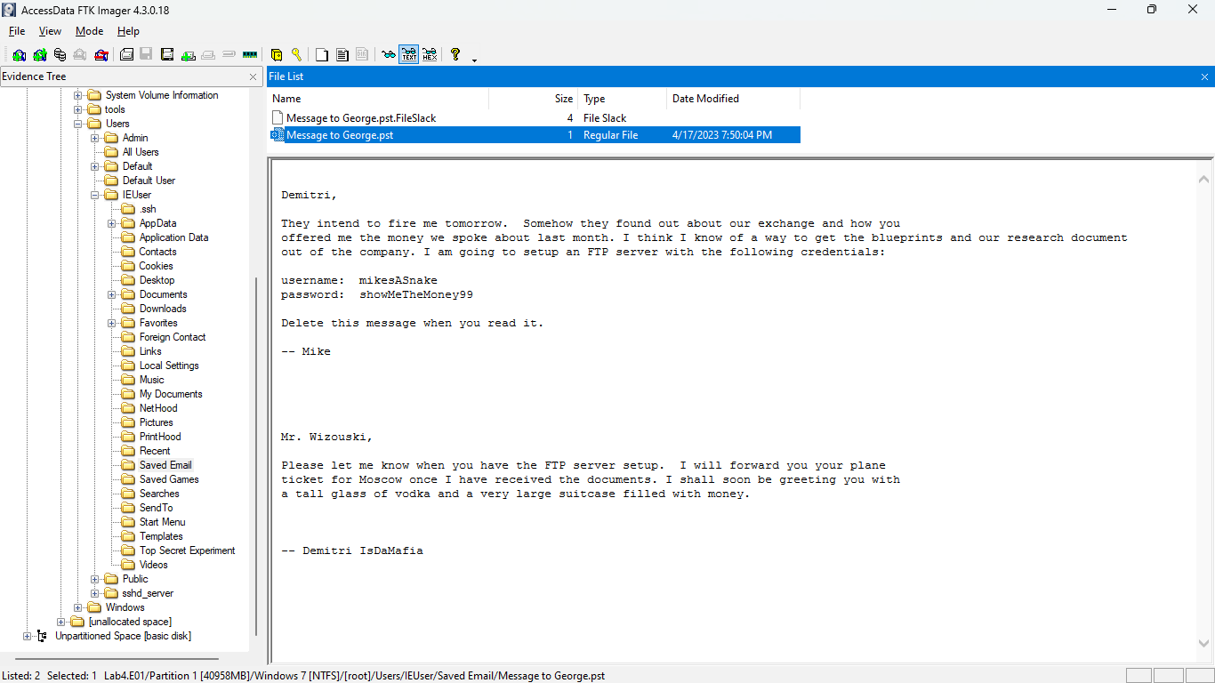

#### Evidence 4

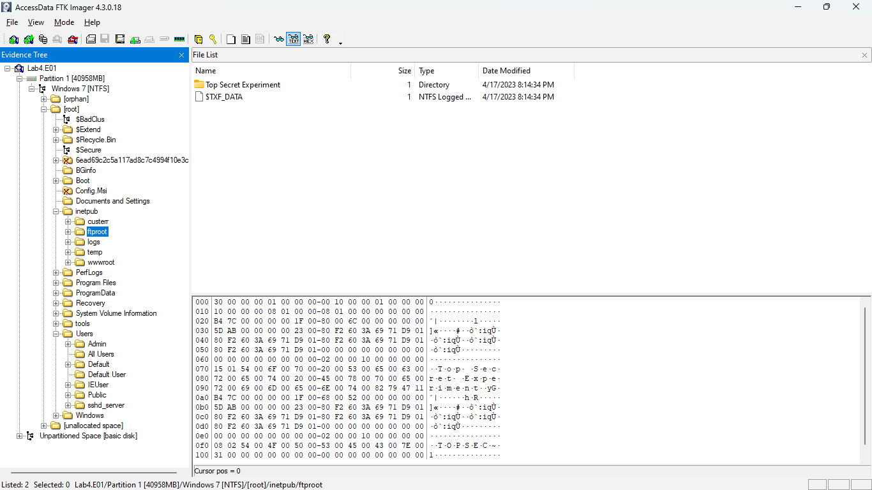

#### Exhibit 5

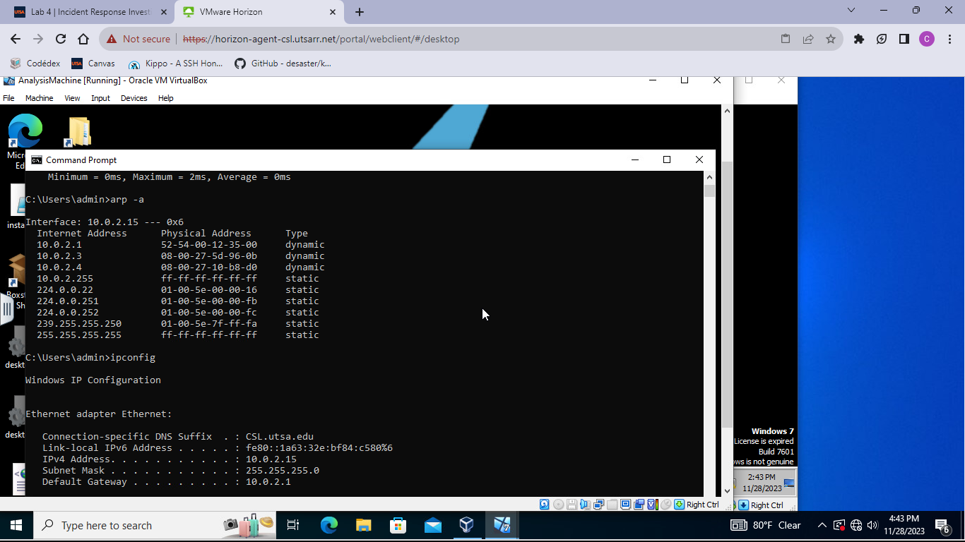

#### Exhibit 6

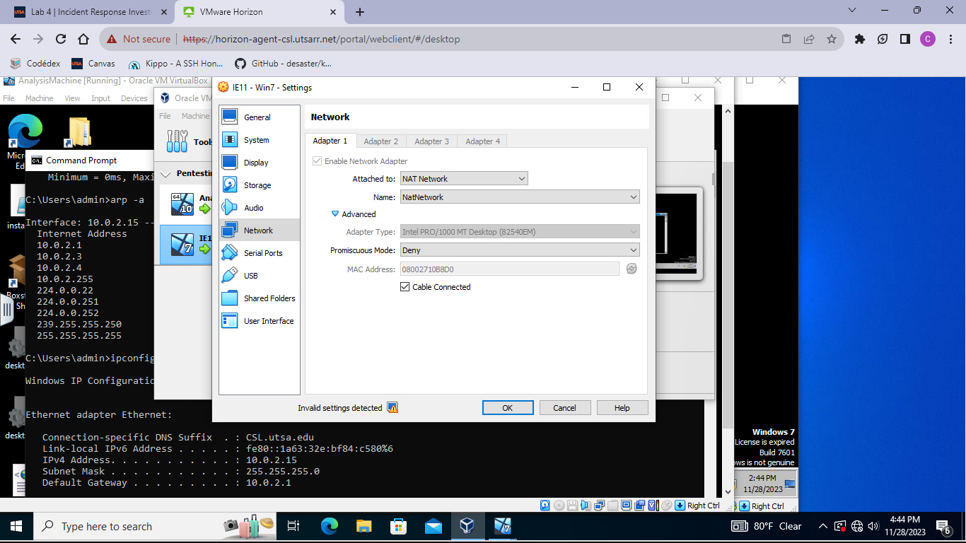

#### Exhibit 7

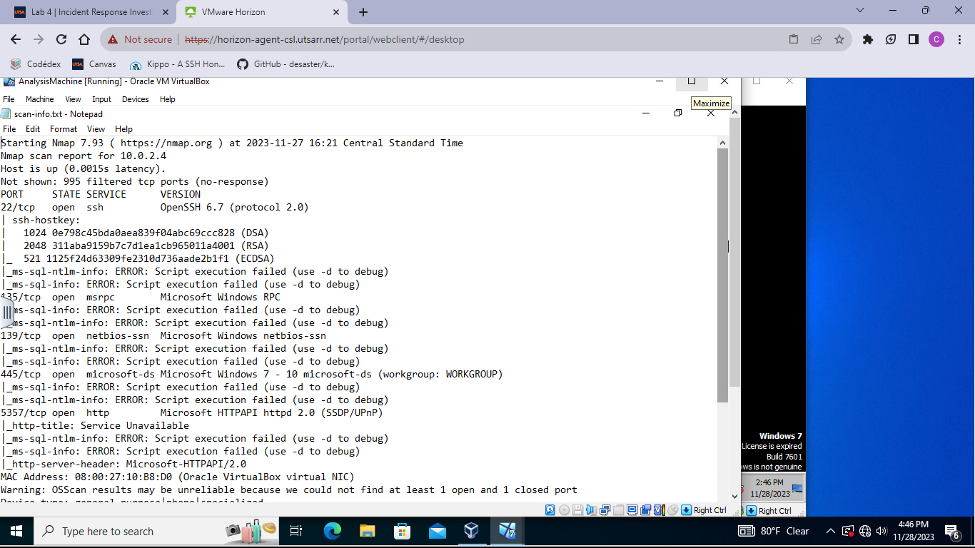

#### Exhibit 8

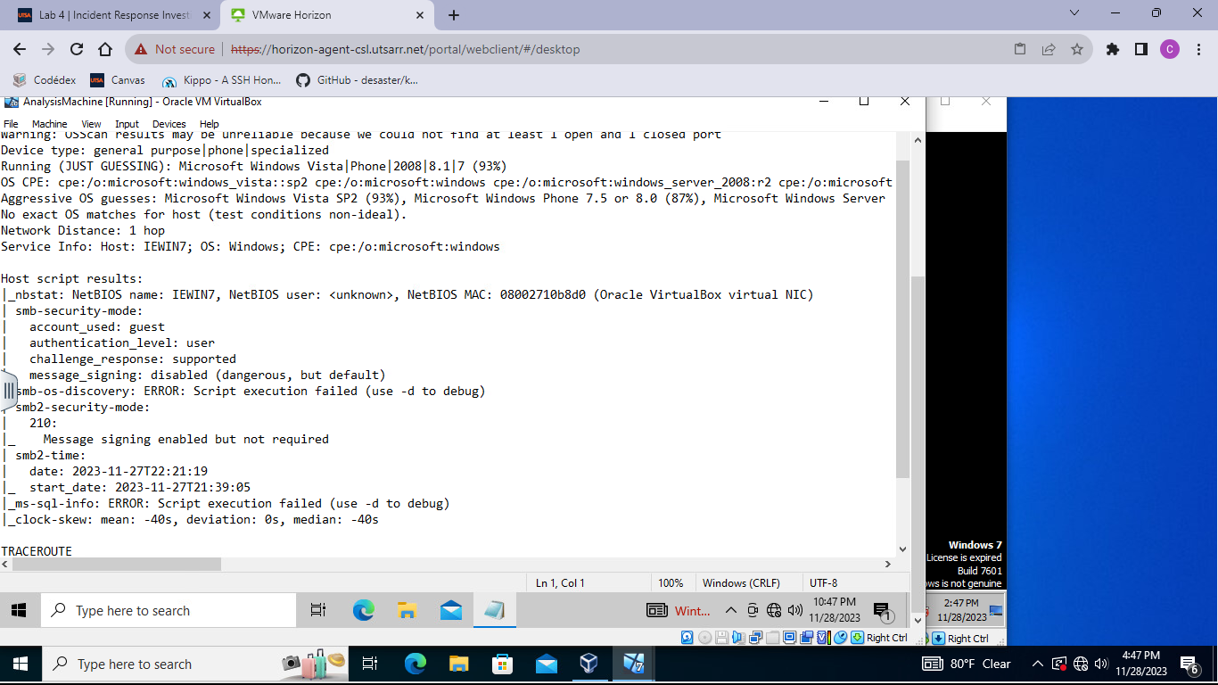

#### Exhibit 9

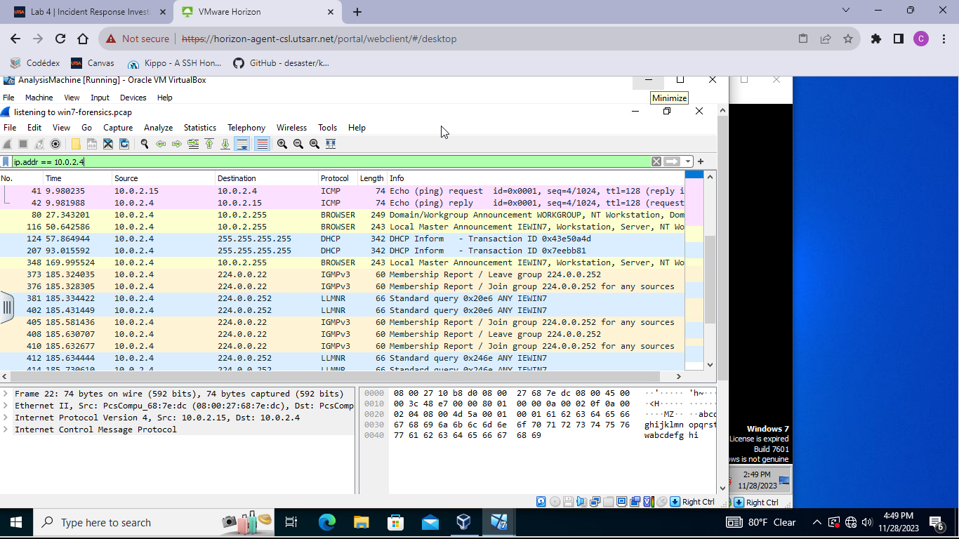

#### Exhibit 10

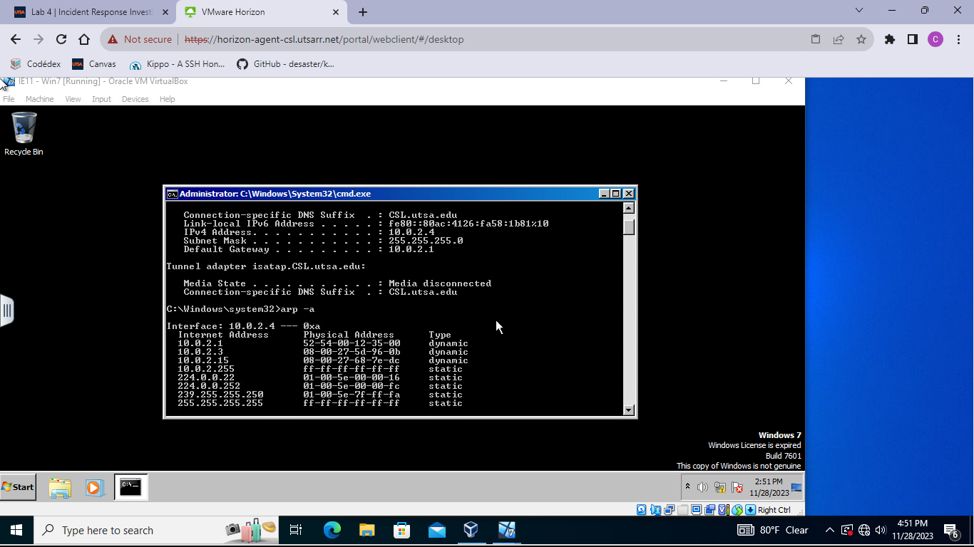

#### Exhibit 11

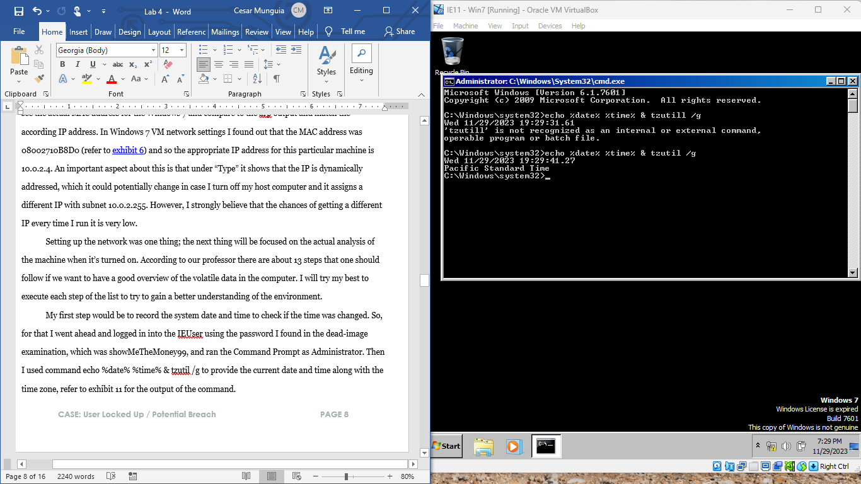

#### Exhibit 12

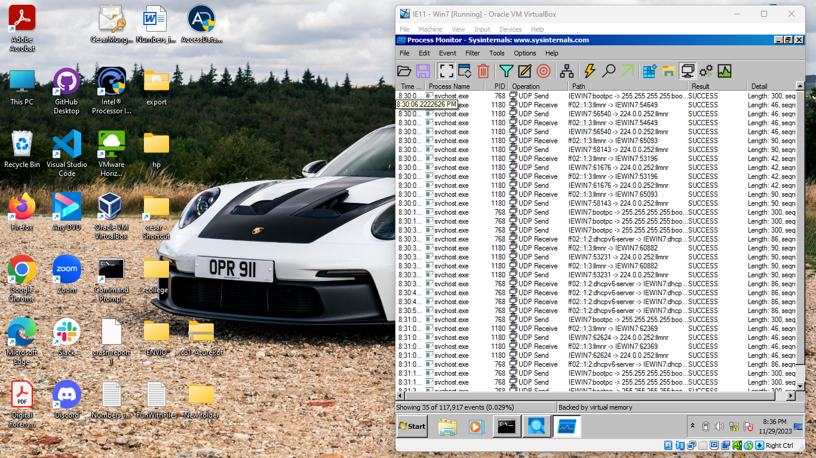

#### Exhibit 13

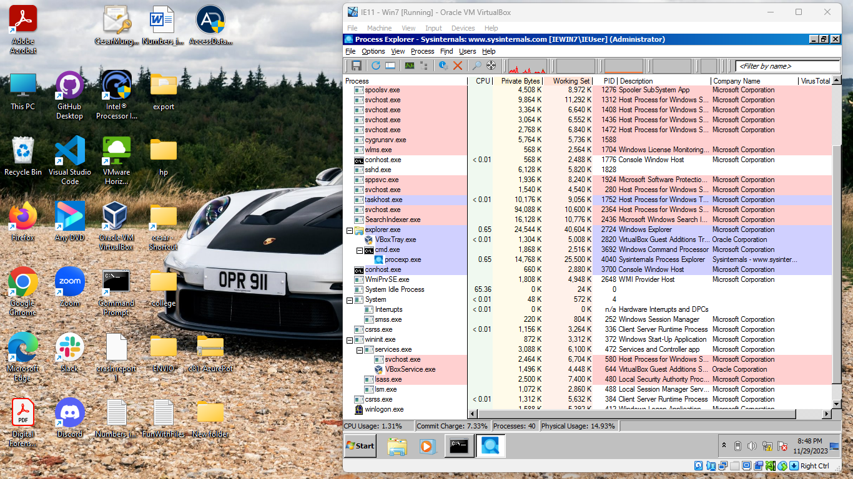

#### Exhibit 14

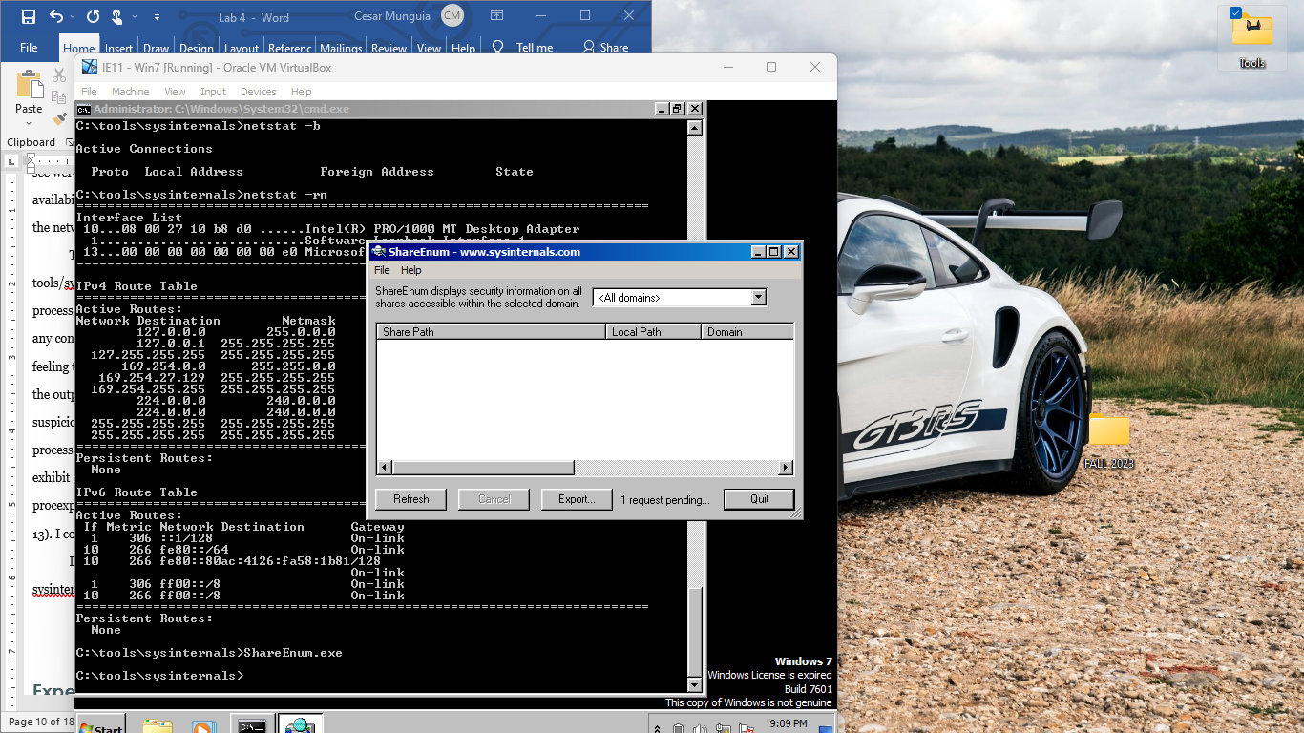

#### Exhibit 15

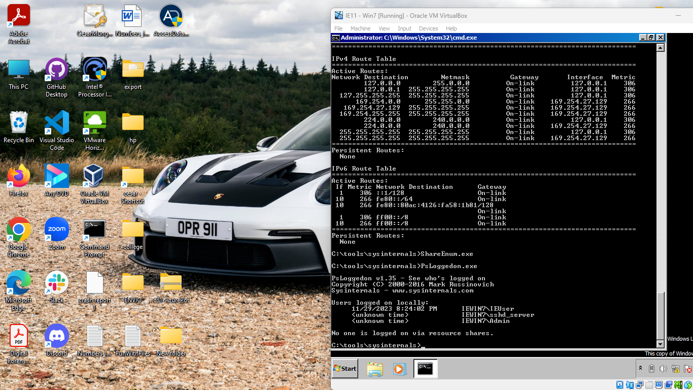

#### Exhibit 16

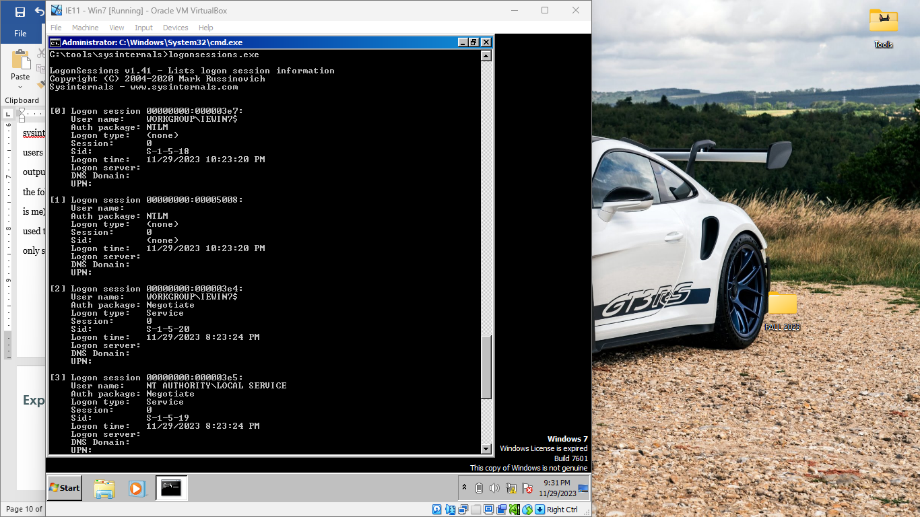

#### Exhibit 17

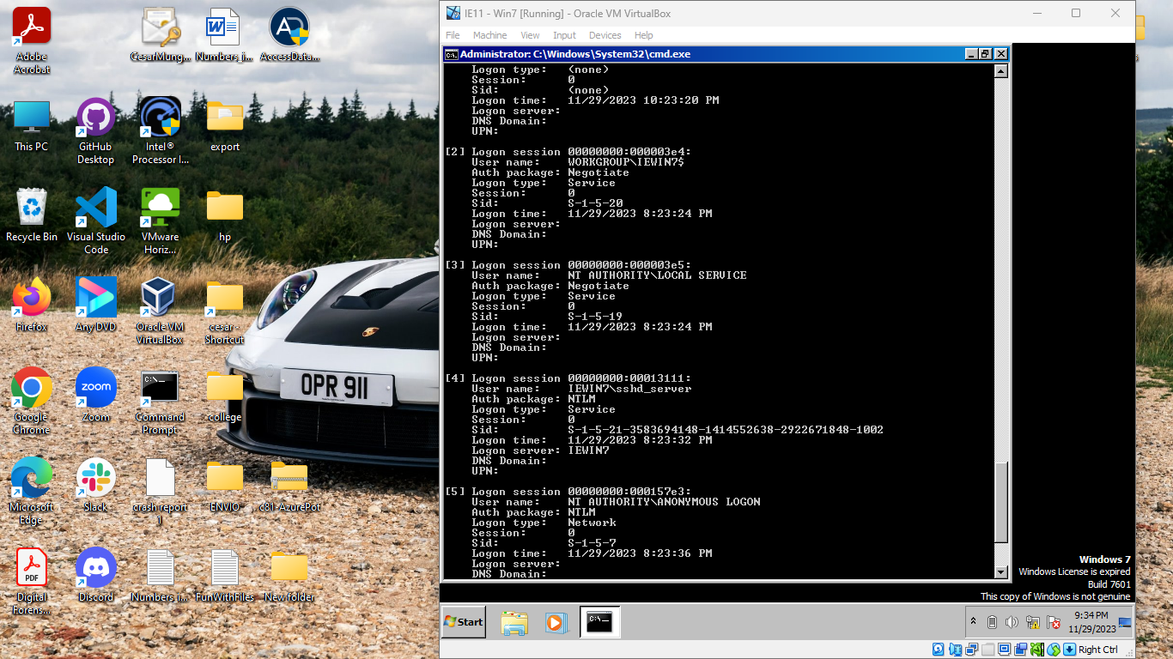

#### Exhibit 18

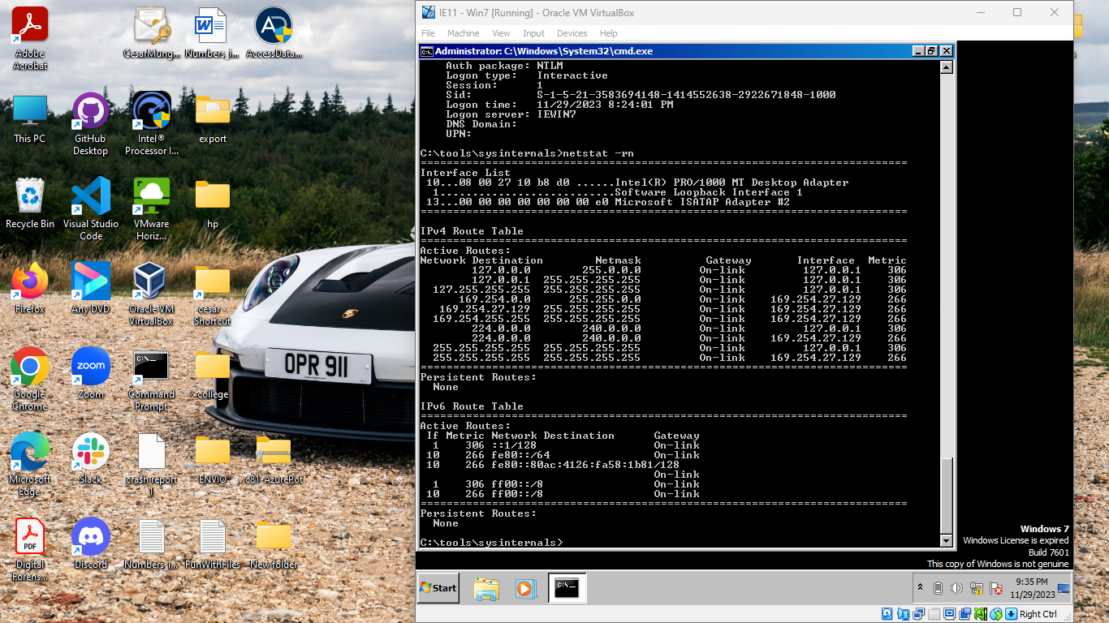

#### Exhibit 19

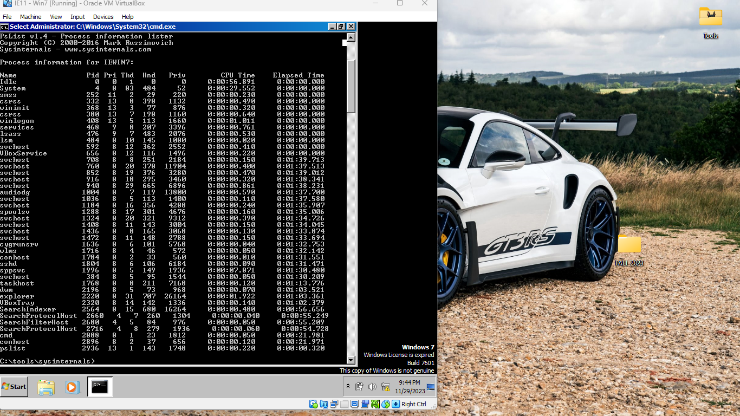

#### Evidence 20

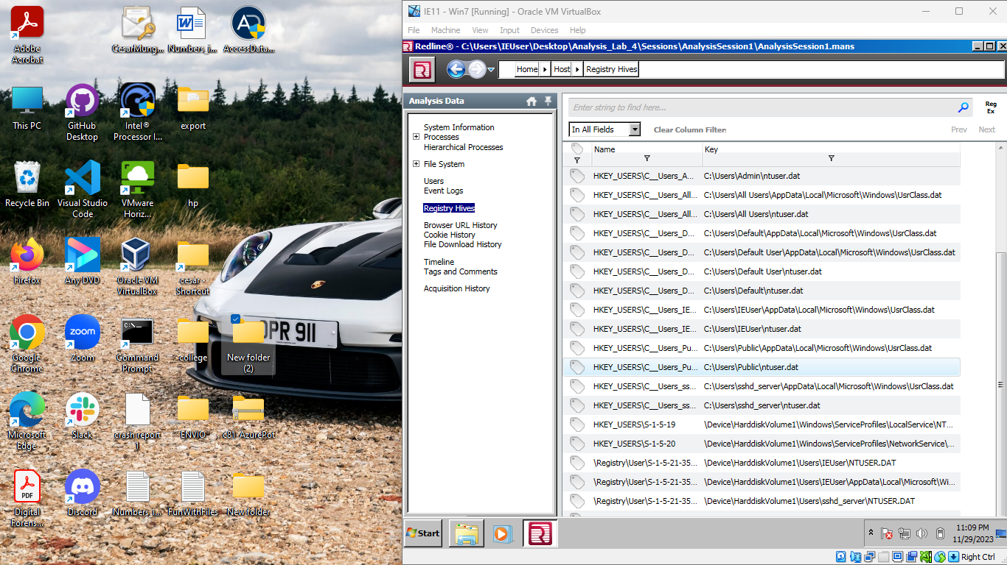

#### Evidence 21

